Project Design Phase: Solution Architecture
Date | 30 September 2026
Team ID
Project Name | SHOPEZ : E-commerce Application
Maximum Marks | 4 Marks
1. Solution Architecture Overview
Solution architecture bridges the requirements of the stock trading platform and its technical implementation. Its core objectives include:
• Identifying suitable technical solutions for secure stock browsing, simulated trading, and portfolio management.
• Describing the software components, structure, interactions, and behavior for investors and administrators.
• Defining the application modules, database components, authentication mechanisms, and API interactions.
• Establishing technical specifications for development, testing, security, monitoring, and future scalability.
2. Proposed Solution Architecture Diagram
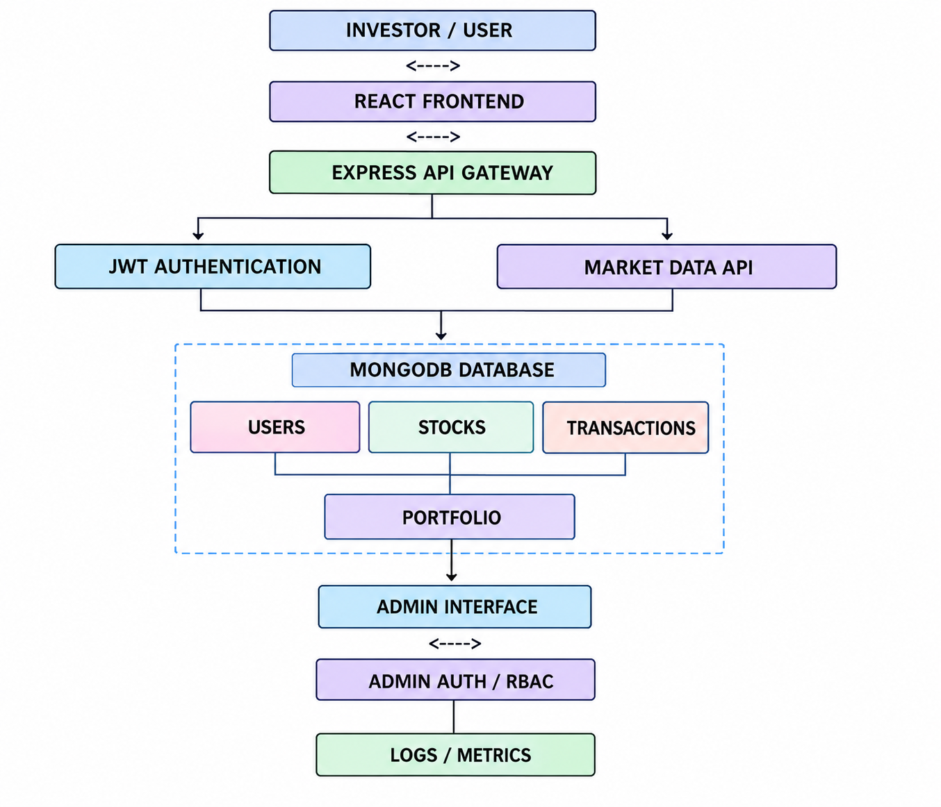
Figure 1: High-level MERN stack architecture flow for the Stock Trading & Portfolio Management System.
3. Architecture Component Description
Component | Technology | Purpose
Investor / User Interface | React.js, HTML, CSS, Bootstrap | Provides registration, login, stock browsing, search, stock details, buy/sell forms, portfolio tracking, and transaction history.
Frontend Communication | Axios | Sends authenticated requests from the React application to backend REST APIs and receives market, trading, and portfolio data.
API Gateway / Backend | Node.js, Express.js | Handles API routing, validation, business logic, CRUD operations, authentication middleware, and trading workflows.
Authentication & Security | JWT, bcrypt.js, CORS | Provides token-based authentication, password hashing, protected routes, role-based access, and controlled API access.
Market Data Integration | Axios / External Stock API | Retrieves current or periodically updated stock prices and market information when an external API is configured.
Database | MongoDB, Mongoose | Stores users, stocks, transactions, portfolio holdings, balances, and related application records.
Portfolio & Trading Engine | Node.js / Express.js | Validates virtual balance and quantity, executes simulated buy/sell operations, records transactions, and updates portfolio holdings.
Admin Interface | React.js | Allows authorized administrators to manage users, stock records, transactions, and platform activity.
Monitoring | Express logging / application logs | Supports server logging, centralized error handling, activity monitoring, and troubleshooting.
4. Architecture Flow
The investor interacts with the React frontend. Requests are sent through Axios to protected Express.js APIs. Authentication is handled using JWT tokens and bcrypt.js password hashing. The backend processes stock searches, market information, and simulated buy/sell transactions. MongoDB stores user, stock, transaction, and portfolio data. The administrator accesses a protected admin interface to manage records and monitor platform activity.

